 (BE-2013) CSE

**(Annexure A)**

**INTEGRATED PROJECT REPORT**

**On**

**INTERNET OF THINGS**

Submitted in partial fulfillment of the requirement for the

Course Integrated Project (CSP3203) of

**COMPUTER SCIENCE AND ENGINEERING**

**B.E. Batch-2013**

**in**

**June -2016**



|  |  |
| --- | --- |
| **Under the Guidance of** | **Submitted By** |
|  | Abhishek Mahendru |
| Deepinder Virk (Assistant Professor) | (CUN130101013) |
|  | Adeshpaul Singh Gill |
|  | (CUN130101016) |
|  | Akshay Dhiman |
|  | (CUN130101024) |
|  | Akshita Sharma |
|  | (CUN130101028)  Mannat Ahluwalia  (CUT130101434) |

**SCHOOL OF COMPUTER SCIENCES**

**CHITKARA UNIVERSITY**

**PUNJAB**



 (BE-2013) CSE

**(Annexure B)**

**INTEGRATED PROJECT REPORT**

**On**

**INTERNET OF THINGS**

Submitted in partial fulfillment of the requirement for the

Course Integrated Project (CSP3203) of

**COMPUTER SCIENCE AND ENGINEERING**

**Batch-2013**

**in**

**June -2016**

|  |  |
| --- | --- |
| **Under the Guidance of** | **Submitted By** |
|  | Abhishek Mahendru |
| Deepinder Virk (Assistant Professor) | (CUN130101013) |
|  | Adeshpaul Singh Gill |
|  | (CUN130101016) |
|  | Akshay Dhiman |
|  | (CUN130101024) |
|  | Akshita Sharma |
|  | (CUN130101028)  Mannat Ahluwalia  (CUT130101434) |

**SCHOOL OF COMPUTER SCIENCES**

**CHITKARA UNIVERSITY**

**PUNJAB**

(BE-2013) CSE

**(Annexure –C)**

**CERTIFICATE**

This is to be certified that the project entitled “INTERNET OF THINGS” has been submitted for the Bachelor of Computer Science Engineering at Chitkara University, Punjab during the academic semester January 2016- June-2016 is a bonafide piece of project work carried out by “Abhishek Mahendru(CUN130101013),AdeshpaulSinghGill(CUN130101016),Akshay Dhiman(CUN130101024),Akshita Sharma (CUN130101028) and Mannat Ahluwalia(CUT130101434)” towards the partial fulfillment for the award of the course Integrated Project (CSP3203) under the guidance of “Deepinder Virk” and supervision.

**Sign.of Project Guide** :

Deepinder Virk

(Assistant Professor & Computer Science Department)

 (BE-2013) CSE

**(Annexure –D)**

**CANDIDATE’S DECLARATION**

We, **Abhishek Mahendru (CUN130101013),Adeshpaul Singh Gill (CUN130101016), Akshay Dhiman(CUN130101024),Akshita Sharma (CUN130101028),Mannat Ahluwalia (CUT130101434)**,B.E.-2013 of the Chitkara University, Punjab hereby declare that the Integrated Project Report entitled **“INTERNET OF THINGS”** is an original work and data provided in the study is authentic to the best of our knowledge. This report has not been submitted to any other Institute for the award of any other course.

|  |  |  |  |  |  |
| --- | --- | --- | --- | --- | --- |
| **Sign. of Student 1** | **Sign. of Student 2** | **Sign. of Student 3** | **Sign. of Student 4** | | **SiC** |
| Abhishek Mahendru | Adeshpaul Singh Gill | Akshay Dhiman | | Akshita Sharma |  |
| CUN130101013 | CUN130101016 | CUN130101024 | | CUN130101028 |  |

|  |
| --- |
| **Sign. of Student 4** |
| Mannat Ahluwalia |
| CUT130101434 |

**Place: Chitkara University**

**Date: 21/05/2016**



(BE-2013) CSE

**(Annexure -E )**

**ACKNOWLEDGEMENT**

It is our pleasure to be indebted to various people, who directly or indirectly contributed in the development of this work and who influenced my thinking, behavior and acts during the course of study.

We express our sincere gratitude to all for providing me an opportunity to undergo Integrated Project as the part of the curriculum.

We are thankful to ***“Deepinder Virk”***  for his support, cooperation, and motivation provided to us during the training for constant inspiration, presence and blessings.

We also extend our sincere appreciation to ***“Deepinder Virk”*** who provided his valuable suggestions and precious time in accomplishing our Integrated project report.

Lastly, We would like to thank the almighty and our parents for their moral support and friends with whom we shared our day-to day experience and received lots of suggestions that improve our quality of work.

|  |  |  |  |
| --- | --- | --- | --- |
| Abhishek Mahendru | Adeshpaul Singh Gill | Akshay Dhiman | Akshita Sharma |
| CUN130101013 | CUN130101016 | CUN130101024 | CUN130101028 |

Mannat Ahluwalia

CUT130101434



**TABLE OF CONTENTS**

1. Abstract
2. Introduction

2.1 Problem Statement

2.2 Objectives&Key Learning

2.3 Background

1. Purpose of Project and overview
2. Software and Hardware Requirements Specifications
3. Project’s Structure Analyzing and GUI Constructing(Screenshots)
4. Code Implementation.
5. Results
6. Limitations
7. Conclusion
8. Future Scope
9. References





**ABSTRACT**

Internet of Things (IoT) is a concept that envisions all objects around us as part of internet. IoT coverage is very wide and includes variety of objects like smart phones, tablets, digital cameras and sensors. Once all these devices are connected to each other, they enable more and more smart processes and services that support our basic needs, environment and health. Such enormous number of devices connected to internet provides many kinds of services. They also produce huge amount of data and information.

This project presents the overall design of Home Automation System (HAS) with low cost and wireless system. This system is designed to assist and provide support in order to fulfill the needs of elderly and disabled in home. Also, the smart home concept in the system improves the standard living at home which presents design and implementation concepts for a wireless real-time home automation system based on Arduino Uno microcontroller as central controllers. It allows the user to control it with a wireless device such as a Wi-Fi or Bluetooth enabled mobile phone. A desktop PC is used to run the server software. The system allows the user to control each of the lights and fans individually. The main control system implements wireless technology to provide remote access from smart phone. The design remains the existing electrical switches and provides more safety control on the switches with low voltage activating method. The switches status is synchronized in all the control system whereby every user interface indicates the real time existing switches status. The system intended to control devices in house with relatively low cost design, user-friendly interface and ease of installation.

**Keywords**: Internet of Things, WifiModule, Arduino UNO board,,Home Automation.

**INTRODUCTION**

**Problem Statement:**

Internet of Things (IoT) is a concept that visualizes all objects around us as part of internet.

Applications that interact with devices like sensors have special requirements of huge storage

to store big data, huge computation power to enable the real time processing of the data i.e

information, and high speed network to stream audio or video. Design an application which

describes how IoT and Cloud computing can work together to provide automation of

domestic things so as to reduce human intervention and save time and energy.

**Objective & Key Learning:**

* To design and implement a control and monitor system for smart house.
* To assist handicapped / old aged people.
* To give a basic idea of how to control various

Home appliances and provide a security using phone/tab.



**BACKGROUND**

A typical home automation system allows one to control house hold appliances from a centralized control unit. These appliances include lights, fans, air conditioners, television sets,

security cameras, electronic doors, computer systems, audio/visual equipment, etc. These

appliances usually have to be specially designed to be compatible with each other and with the

control unit for most commercially available home automation systems. The project

“Implementation of a Low-Cost Home Automation System”, demonstrates a system that can be

integrated into a building’s electrical system and allows one to wirelessly control lights, fans, and turn on or off them that are plugged into a wall outlet. The system can be controlled from a Wi-Fi enabled device such as a mobile phone or laptop, while a Arduino acts as the server. Thus the installation cost and hardware cost is kept to a minimum as most users already own the requisite hardware such as a mobile phone and desktop PC. A standard Wireless Access Point is used to provide connectivity between the server and the mobile/laptop/tab.

**PURPOSE AND OVERVIEW**

The main focus of our research is to reduce the overall cost of the system. To make a property smarter and more enjoyable to live in and live with ,which is reliable, intuitive, easy to use and meets and exceeds the expectations.To simplify your life. With that goal, webpage is created from which you control mutiple devices like fan,bulb,other devices,etc.Property owners can save on utility charges by being able to turn things on/off without direct intervention. Home automation systems are easy to use and simple to connect to your electronic device (i.e. smartphone or tablet). This is a low cost service device in which a relay switch is used to send control signals from the micro-controller to the electronic device used to achieve the switching on and off action. A web portal is designed with a one-factor authentication system (Ip address) to check authenticity of the home user. It acts as an input device to control the home appliances and also acts as an output device to read the values.

**SOFTWARE AND HARDWARE REQUIREMENT**



**METHODS AND DESIGN APPROACH**

A low cost and efficient smart home system is presented in our design. This system has two main modules: the hardware interface module and the software communication module. At the heart of this system is the Arduino UNO microcontroller which is also capable of functioning as a micro web server and the interface for all the hardware modules. All communication and controls in this system pass through the microcontroller. It offers switching functionalities to control lighting, fans and other home appliances connected to the relay system.

**SOFTWARE REQUIREMENTS**

* Arduino IDE (version 1.5 or above)
* Web Browser (Google Chrome/Firefox)

**HARDWARE REQUIREMENTS**

* Arduino Uno
* ESP8266 Module
* Relay
* Breadboard
* Jumper Cables
* Lights

**PROJECT SNAPSHOTS**

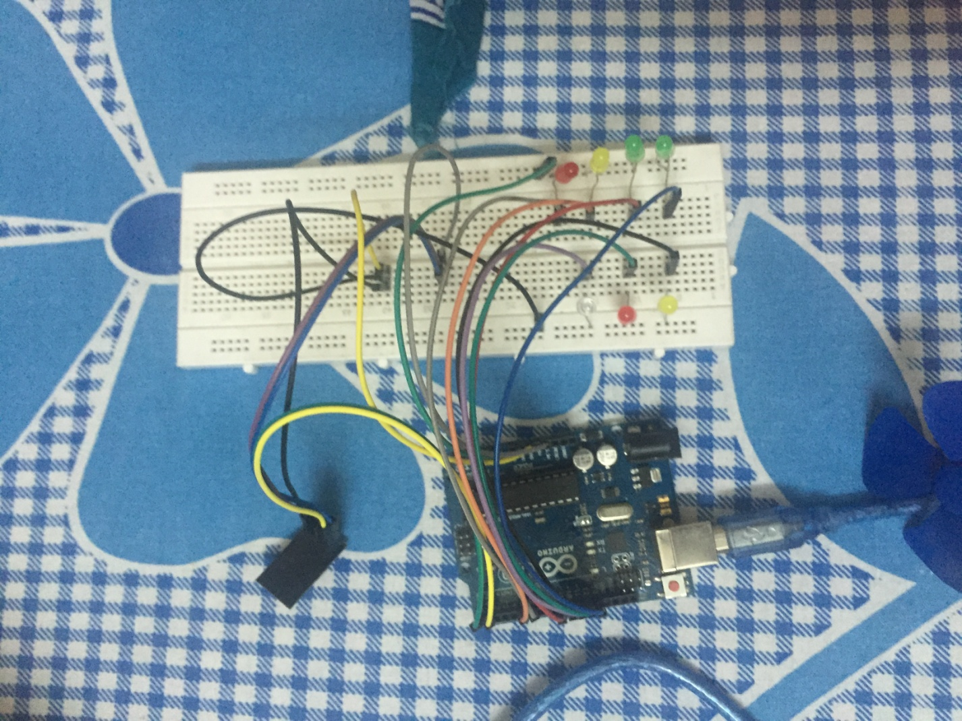

**(1)**

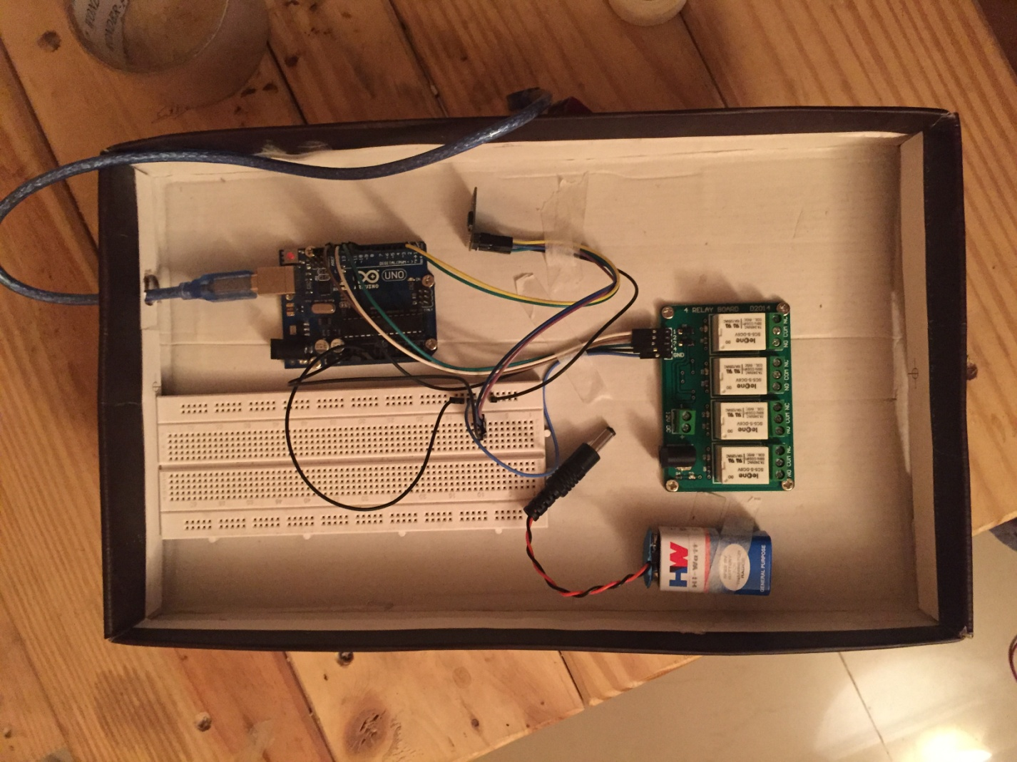

**(2)**

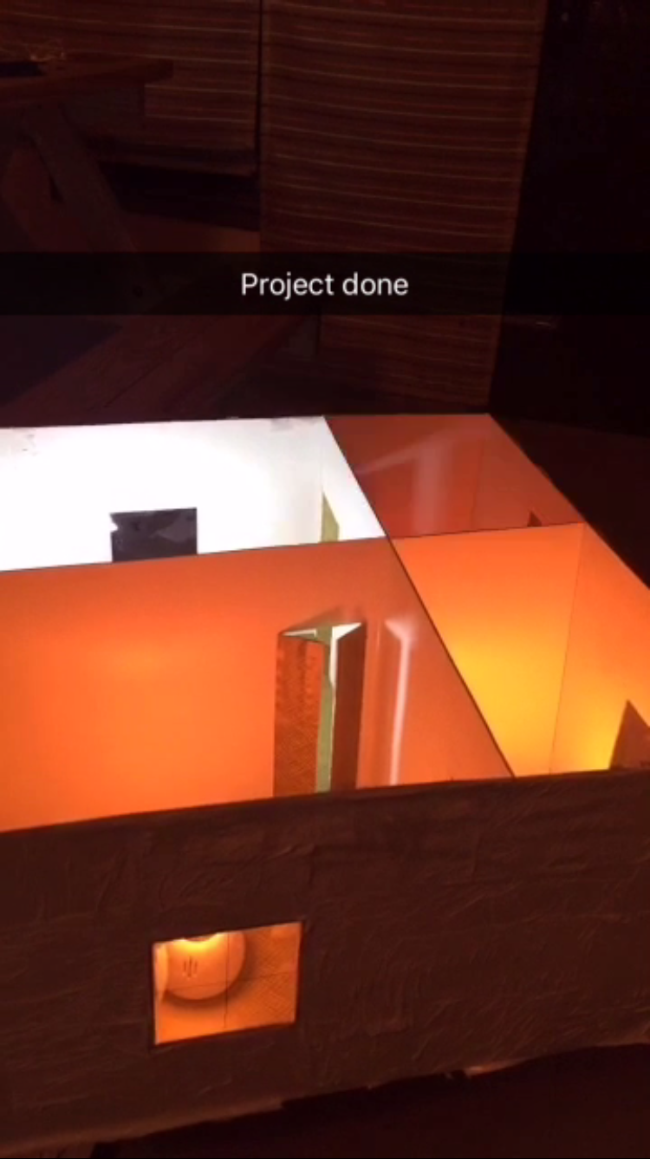

**(3)**

**PROJECT STRUCTURE**

Below is the system architecture: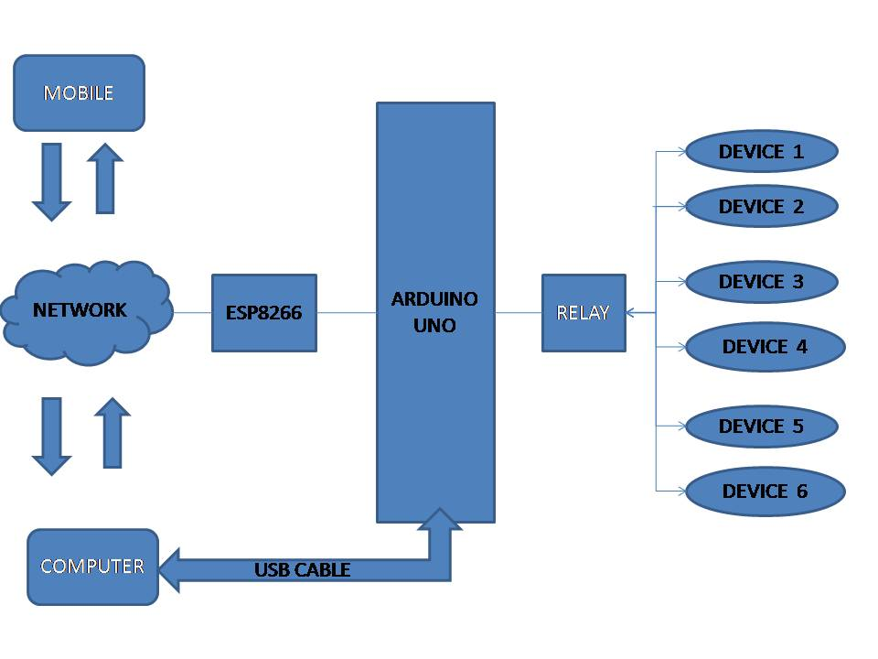

**FLOW CHART OF PROJECT**

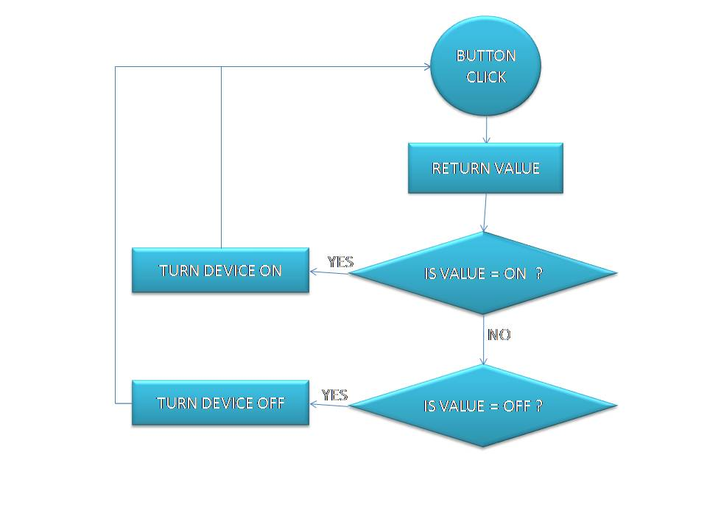

**CODE IMPLEMENTATION**

String fromNetwork;

void setup()

{

Serial.begin(115200);

Serial.println("AT+CIPMUX=1");

delay(10);

Serial.println("AT+CIPSERVER=1,1883");

pinMode(12,OUTPUT);

digitalWrite(12,LOW);

pinMode(11,OUTPUT);

digitalWrite(11,LOW);

pinMode(13,OUTPUT);

digitalWrite(13,LOW);

pinMode(10,OUTPUT);

digitalWrite(10,LOW);

pinMode(9,OUTPUT);

digitalWrite(9,LOW);

pinMode(5,OUTPUT);

digitalWrite(5,LOW);

}

void loop()

{

if(Serial.available())

{

fromNetwork.concat((char)Serial.read());

if(fromNetwork.indexOf("CONNECT")>-1)

{

Serial.println("AT+CIPSEND=0,1116");//-116-24

delay(50);

Serial.println("<html><title>ESP8266 Control</title><STYLE>H1,h2,div{TEXT-ALIGN:CENTER;}button{padding:16px 32px;margin: 4px 2px;}");

Serial.println("</STYLE><body><form method='GET'><H1>HOME AUTOMATION</H1><h2>LIVING ROOM</h2><div><button type='submit' name='b' value='BULB ON'>BULB ON</button><button class='center' name='b' type='submit' value='BULB OFF'>BULB OFF</button><br/><button type='submit' name='c' value='FAN ON'>FAN ON</button>");

Serial.println("<button type='submit' name='c' value='FAN OFF'>FAN OFF</button></div><h2>BEDROOM</h2><div><button type='submit' name='d' value='HEATER ON'>BULB ON</button><button type='submit' name='d' value='HEATER OFF'>BULB OFF</button><br/>");

Serial.println("<button type='submit' name='e' value='LIGHT ON'>FAN ON</button><button type='submit' name='e' value='LIGHT OFF'>FAN OFF</button></div><h2>KITCHEN</h2><div><button type='submit' name='f' value='CFL ON'>BULB ON</button>");

Serial.println("<button type='submit' name='f' value='CFL OFF'>BULB OFF</button><br/></div><h2>WASHROOM</h2><div><button type='submit' name='g' value='MIC ON'>BULB ON</button><button type='submit' name='g' value='MIC OFF'>BULB OFF</button><br/></div>");

Serial.println("</form></body></html>");

fromNetwork="";}

else if(fromNetwork.indexOf("BULB+ON")>-1)

digitalWrite(12,HIGH);

else if(fromNetwork.indexOf("BULB+OFF")>-1)

digitalWrite(12,LOW);

else if(fromNetwork.indexOf("FAN+ON")>-1)

 digitalWrite(11,HIGH);

else if(fromNetwork.indexOf("FAN+OFF")>-1)

digitalWrite(11,LOW);

else if(fromNetwork.indexOf("HEATER+ON")>-1)

digitalWrite(13,HIGH);

else if(fromNetwork.indexOf("HEATER+OFF")>-1)

digitalWrite(13,LOW);

else if(fromNetwork.indexOf("LIGHT+ON")>-1)

digitalWrite(10,HIGH);

else if(fromNetwork.indexOf("LIGHT+OFF")>-1)

digitalWrite(10,LOW);

else if(fromNetwork.indexOf("CFL+ON")>-1)

digitalWrite(9,HIGH);

else if(fromNetwork.indexOf("CFL+OFF")>-1)

digitalWrite(9,LOW);

else if(fromNetwork.indexOf("MIC+ON")>-1)

digitalWrite(5,HIGH);

else if(fromNetwork.indexOf("MIC+OFF")>-1)

digitalWrite(5,LOW);

}

}

**RESULTS**

We have tested this system for appropriate outputs; the following section includes experimental section of these. The system is checked for multiple inputs corresponding to the desired output.

USER END:

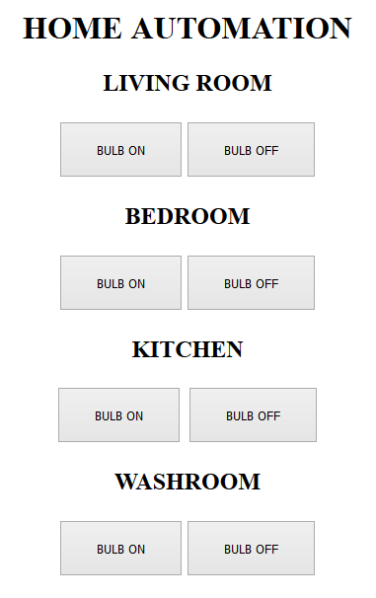

**LIMITATIONS**

1. **Low memory of arduino and Esp8266 doesnot allow to connect more devices:**Due to the low memory of arduino UNO and Esp8266 , they doesn’t allow more devices to connect which is quite a loss for it.
2. **Sometimes feedback may be delayed :** Using Esp8266 with arduino UNO, it may delay the feedback required to run the project.
3. **Esp8266 interferes with arduino sketch uploading:** The moment a sketch is uploaded in the arduino Esp8366 interferes with it and creates a lot fuzz and sometimes crashes the program.
4. **System crashes due to any damage in the interconnection:**If there is any damage due to rupturing of cables or the fibers the entire system gets crashed. This will not be the case of radio signals or the other signals. Here there will be a problem of signal receiving. The wiring of the system results in crash in most of the systems.
5. **Human errors:** If the human does not handle the kit safely or if he/she does not use the correct keys to perform the operations, human errors may occur. Human errors also lead to destructions of the machine. Then there will be a huge system crash.



**CONCLUSION**

A design concept for a wireless real-time home automation system based on Arduino Uno microcontroller as central controller has been obtained. The proposed technique provided

that the automated system has one operational modes, where the mode used a manually-

automated mode technique in which users can monitor and control their home appliances

from anywhere in the house using smart phone/computer through Wi-Fi communication

technology. A hardware implementation of the system was carried out to verify the

reliability of the system. The implemented system was a simple, low cost and flexible that

can be expanded and scaled up.

Home Automation is undeniably a resource which can make a home environment automated. People can control their electrical devices via these Home Automation devices and set up controlling actions through Mobile.

The prime objective of our project is to use the Smartphone to control the home

appliances effectively. The switch mode is used to control the home appliances. This project is based on the Arduino UNO. This platform is Free Open Source Software. So the overall implementation cost is low and can be easily configured. User can easily interact with the android phone/tablet. The user can send commands via the switch mode . The data are being analyzed and are sent over a network. The Arduino UNO acts as a server, analyses the data and activates the GPIO (General Purpose Input Output) Pins. The GPIO Pins are

connected to the relays switch which activated the required home appliances.

In this way, automation process is carried out. This is a simple prototype. Using this

as a reference further it can be expanded to many other programs.

**FUTURE SCOPE**

The Project has been implemented on Arduino Uno. In Future we can make certain changes such as this project will be put up on the Raspberry Pi . Also, a future improvement can be added to the propose system using wireless sensor technologies. The proposed system can be developed and fabricated as a commercial hardware package. To implement control of multiple appliances or automatic detection of faults in the controlled appliance. Using this system as framework, the system can be expanded to include various other options which could include home security feature like capturing the photo of a person moving around the house and storing it onto the cloud. This will reduce the data storage than using the CCTV camera which will record all the time and stores it. The system can be expanded for energy monitoring, or weather stations. This kind of a system with respective changes can be implemented in the hospitals for disable people or in industries where human invasion is impossible or dangerous, and it can also be implemented for environmental monitoring.

**REFERENCES**

1. D. Giusto, A. Iera, G. Morabito, L. Atzori (Eds.), The Internet of Things, Springer, 2010. ISBN:978-1-4419-1673-0.
2. INFSO D.4 Networked Enterprise & RFID INFSO G.2 Micro &Nano systems, in: Co-operation with the Working Group RFID of the ETP EPOSS, Internet of Things in 2020, Roadmap for the Future, Version 1.1, 27 May 2008.
3. B. Sterling, Shaping Things – Media work Pamphlets, The MIT Press, 2005.
4. INTERNET Auto-Id Labs, <http://www.autoidlabs.org/>.
5. National Intelligence Council, Disruptive Civil Technologies – Six Technologies with Potential Impacts on US Interests Out to 2025 –Conference Report CR 2008-07, April 2008,<http://www.dni.gov/nic/NIC_home.html>.L. Atzori et al. / Computer Networks 54 (2010) 2787–2805 2803
6. Bill N. Schilit, Norman Adams, and Roy Want, “Context-Aware Computing Applications”
7. ["Wireless Sensor Networks: Concepts, Applications, Experimentation and Analysis"](https://books.google.com/books?id=oYmwCwAAQBAJ&pg=PA108&lpg=PA108&source=bl&sa=X#v=onepage&f=false). 2016. p. 108. [ISBN](https://en.wikipedia.org/wiki/International_Standard_Book_Number) [9811004129](https://en.wikipedia.org/wiki/Special:BookSources/9811004129). The use of standardized, open communication protocols over proprietary protocols provides the industry with the freedom to choose between suppliers with guaranteed interoperability. Standardized solutions usually have a much longer lifespan than proprietary solutions.